Sample Catalogue of Open Access Publications
Smart OA: By Researchers. For Researchers.

Version: 1.0
Dec. 17, 2021

Self-Published by:
Derek BAKER
Middle East Technical University (METU / ODTÜ)
Center for Solar Energy Research and Applications (ODTÜ-GÜNAM)
Ankara, Turkey

This Sample Catalogue of Open Access Publications is shared as an editable file to facilitate its reuse and adaption by other authors seeking pathways to publish Open Access (OA) that embody Plan S principles, maximize the impacts of the published scientific results, and support the scientific careers of the authors. This Catalogue was developed within the framework of Smart OA. The motivation and background for Smart OA are published OA at
D. K. Baker (2021). Guidelines to Support Smart OA. Middle East Technical University. Self-published. DOI: 10.5281/zenodo.5501401: https://zenodo.org/record/5501401.
The motivation for and method to construct this catalogue are published OA at
D. K. Baker (2021). Smart OA Examples. Middle East Technical University. Self-published. DOI: 10.5281/zenodo.5788006: https://zenodo.org/record/5788006.

Document History
Version | Date | Change
1.0 | 17 Dec. 2021 | D. Baker published Version 1.0 Open Access (CC BY SA 2.0) by depositing to Zenodo and OpenMETU.
Cite As: D. K. Baker (2021). Sample Catalogue of Open Access Publications. Middle East Technical University. Self-published. DOI: 10.5281/zenodo.5788559.
License: This work is protected by a Creative Commons Attribution-ShareAlike 4.0 International (CC BY-SA 4.0) License. Others are free to Share (copy and redistribute the material in any medium or format) and Adapt (remix, transform, and build upon the material for any purpose, even commercially) under the following terms:
Attribution- You must give appropriate credit, provide a link to the license, and indicate if changes were made. You may do so in any reasonable manner, but not in any way that suggests the licensor endorses you or your use.
ShareAlike- If you remix, transform, or build upon the material, you must distribute your contributions under the same license as the original.
The licensor cannot revoke these freedoms as long as you follow the license terms.
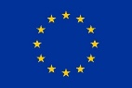
Acknowledgments: Version 1.0 of this catalogue was developed within the framework of the SolarTwins project that received funding from the European Union’s Horizon 2020 research and innovation program under grant agreement No 856619.
Catalogue of Open Access Publications
Derek K. Baker
Prof. Dr.
Department of Mechanical Engineering
Middle East Technical University (METU / ODTÜ)
Concentrating Solar Thermal Division (ODAK)
Center for Solar Energy Research and Applications (ODTÜ-GÜNAM)
Ankara, Turkey
Email: dbaker@metu.edu.tr  Webpage: http://users.metu.edu.tr/dbaker/ |  | ResearcherID: H-2021-2015  ORCID: 0000-0003-4163-1821  Google Scholar: Derek Baker (METU)

About this Catalogue: As of 01 June 2021, I am targeting
- 100% Open Access (OA) publishing for all my journal articles and similar publications;
- Immediate access (i.e. no embargo period) to a publisher approved version of all my publications using a publisher approved route.
This catalogue was specifically developed to facilitate readers in finding an open version of my Green OA publications. Each page of this catalogue is dedicated to one publication and includes links to the different versions of this publication on the web (both OA and subscription based), including a link to at least one version with immediate access. The publications are grouped by type as follows:
1. Peer-Reviewed Scientific Publications (e.g. Journal Articles)
2. Non-Peer Reviewed Publications
About Smart OA: This OA publishing method, including this catalogue, are based on the Smart OA method. The Smart OA method was developed through the European Union Horizon 2020 SolarTwins project to support realization of Plan S principles within a national and institutional context that values publications in high-impact journals but lacks the financial resources to fund Gold OA in these high-impact journals. Within the larger spirit of Plan S, Guidelines to Support Smart OA are published Open Access at Zenodo that include a description of the logic underpinning Smart OA and how to publish Smart OA.

List of and Links to Publications

1. Peer-Reviewed Scientific Publications (e.g. Journal Articles) 3
Johnson, E. F., Tarı, İ., & Baker, D. (2021). Modeling heat exchangers with an open source DEM-based code for granular flows. Solar Energy, 228, 374-386. 4
Mutlu, B., Baker, D., & Kazanç, F. (2021). Development and Analysis of the Novel Hybridization of a Single-Flash Geothermal Power Plant with Biomass Driven sCO2-Steam Rankine Combined Cycle. Entropy, 23(6), 766. 5
Kamfa, I. A., Fluch, J., Bartali, R., & Baker, D. (2020). Solar‐thermal driven drying technologies for large‐scale industrial applications: State of the art, gaps, and opportunities. International Journal of Energy Research, 44(13), 9864-9888. 6
2. Non-Peer Reviewed Publications 7
Baker, D. (2021). Sustainable Development, Well-Earned Surprises, and Bilkent Law. Sine Qua Non, 10, 5. 8

Peer-Reviewed Scientific Publications (e.g. Journal Articles)
Portable Publication Sheet (PPS) for Smart OA*
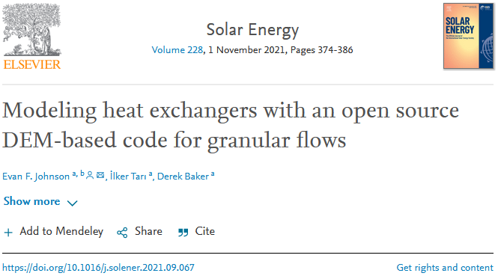
How to Cite |  |  |  |  |  |  | BibTeX
doi | 10.1016/j.solener.2021.09.067 |  |  |  |  |  | @article{johnson2021modeling,  title={Modeling heat exchangers with an open source DEM-based code for granular flows},  author={Johnson, Evan F and Tar{\i}, {\.I}lker and Baker, Derek},  journal={Solar Energy},  volume={228},  pages={374--386},  year={2021},  publisher={Elsevier}  }
MLA | Johnson, Evan F., İlker Tarı, and Derek Baker. "Modeling heat exchangers with an open source DEM-based code for granular flows." Solar Energy 228 (2021): 374-386.
APA | Johnson, E. F., Tarı, İ., & Baker, D. (2021). Modeling heat exchangers with an open source DEM-based code for granular flows. Solar Energy, 228, 374-386.
Chicago | Johnson, Evan F., İlker Tarı, and Derek Baker. “Modeling heat exchangers with an open source DEM-based code for granular flows.” Solar Energy 228 (2021): 374-386.
Harvard | Johnson, E.F., Tarı, İ. And Baker, D., 2021. Modeling heat exchangers with an open source DEM-based code for granular flows. Solar Energy, 228, pp.374-386.
Vancouver | Johnson EF, Tarı İ, Baker D. Modeling heat exchangers with an open source DEM-based code for granular flows. Solar Energy. 2021 Nov 1;228:374-86.
Links to Published Version*
via Journal Website |  |  |  |  | https://www.sciencedirect.com/science/article/pii/S0038092X21008240
via DOI |  |  |  |  | https://doi.org/10.1016/j.solener.2021.09.067
Links to Open Access (OA) Versions
OA Pathway* |  |  |  | Embargo Period? |  | Link
Accepted Version* Pathway a |  |  |  | No |  | http://users.metu.edu.tr/dbaker/OpenAccess/doi.10.1016.j.solener.2021.09.067.pdf
Accepted Version* Pathway b |  |  |  | Yes |  | https://zenodo.org/record/5594171
Accepted Version* Pathway b |  |  |  | Yes |  | https://open.metu.edu.tr/handle/11511/94259
Creative Commons License
 |  |  | The OA Versions are published using a Creative Commons By Attribution – Non-Commercial – No Derivative (CC BY-NC-ND) License (https://creativecommons.org/licenses/by-nc-nd/4.0/)
Cataloging* |  | Derek K. Baker; SolarTwins; ODTÜ-GÜNAM
* Definitions:
Accepted Version: Also referred to as the Author Accepted Manuscript (AAM), is the accepted version of the manuscript submitted to the journal by the author. The Accepted Version does not include any typesetting or final proofing services provided by the journal to convert the Accepted Version into the Published Version. Thus, the Published Version and Accepted Version are identical in terms of scientific content, but differ in terms of formatting and final proofing.
Cataloging: Information to support internal cataloging of this OA publication.
OA Pathway: Defined using Sherpa Romeo (https://v2.sherpa.ac.uk/romeo/). The definitions for the relevant OA Pathways used to publish this work OA are attached as an appendix to the version of the manuscript published OA.
Published Version: Also referred to as the Version of Record (VoR), is the fully-formatted version of the article as published in the journal.
Smart OA: Guidelines to support Smart OA are published OA at https://zenodo.org/record/5501401.
Portable Publication Sheet (PPS) Sheet for Smart OA*
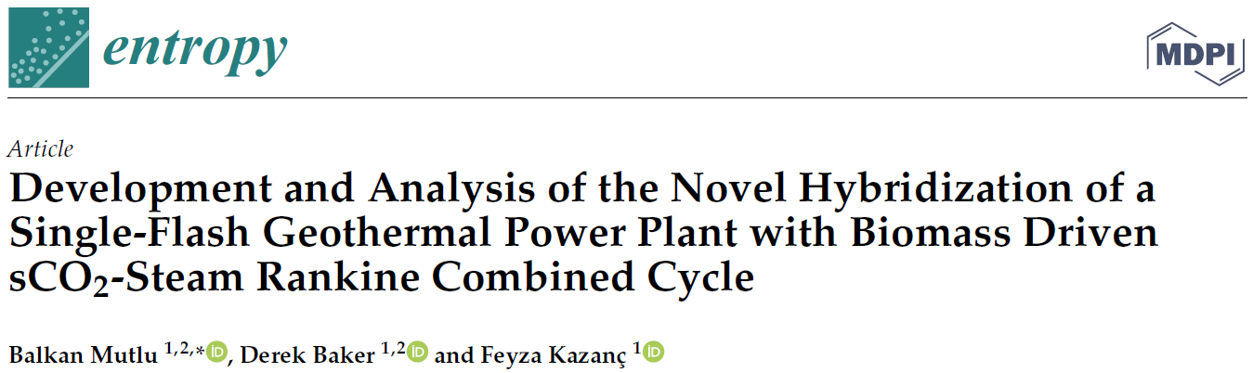
How to Cite |  |  |  |  |  | BibTeX
doi | 10.3390/e23060766 |  |  |  |  | @article{mutlu2021development,  title={Development and Analysis of the Novel Hybridization of a Single-Flash Geothermal Power Plant with Biomass Driven sCO2-Steam Rankine Combined Cycle},  author={Mutlu, Balkan and Baker, Derek and Kazan{\c{c}}, Feyza},  journal={Entropy},  volume={23},  number={6},  pages={766},  year={2021},  publisher={Multidisciplinary Digital Publishing Institute}  }
MLA | Mutlu, Balkan, Derek Baker, and Feyza Kazanç. "Development and Analysis of the Novel Hybridization of a Single-Flash Geothermal Power Plant with Biomass Driven sCO2-Steam Rankine Combined Cycle." Entropy 23.6 (2021): 766.
APA | Mutlu, B., Baker, D., & Kazanç, F. (2021). Development and Analysis of the Novel Hybridization of a Single-Flash Geothermal Power Plant with Biomass Driven sCO2-Steam Rankine Combined Cycle. Entropy, 23(6), 766.
Chicago | Mutlu, Balkan, Derek Baker, and Feyza Kazanç. "Development and Analysis of the Novel Hybridization of a Single-Flash Geothermal Power Plant with Biomass Driven sCO2-Steam Rankine Combined Cycle." Entropy 23, no. 6 (2021): 766.
Harvard | Mutlu, B., Baker, D. and Kazanç, F., 2021. Development and Analysis of the Novel Hybridization of a Single-Flash Geothermal Power Plant with Biomass Driven sCO2-Steam Rankine Combined Cycle. Entropy, 23(6), p.766.
Vancouver | Mutlu B, Baker D, Kazanç F. Development and Analysis of the Novel Hybridization of a Single-Flash Geothermal Power Plant with Biomass Driven sCO2-Steam Rankine Combined Cycle. Entropy. 2021 Jun;23(6):766.
Links to Open Access (OA) Versions
OA Pathway* |  |  |  | Embargo Period? | Link
Published Version*, via Journal Website |  |  |  | No | https://www.mdpi.com/1099-4300/23/6/766
Published Version*, via DOI |  |  |  | No | https://doi.org/10.3390/e23060766
Published Version*, via Zenodo |  |  |  | No | https://zenodo.org/record/5160015
Published Version*, via OpenMETU |  |  |  | No | https://open.metu.edu.tr/handle/11511/91143
Creative Commons License
 |  |  | The OA Versions are published using a Creative Commons By Attribution 4.0 (CC BY 4.0) License: https://creativecommons.org/licenses/by/4.0/.
Cataloging* |  | Derek K. Baker; SolarTwins; ODTÜ-GÜNAM
* Definitions:
Accepted Version: Also referred to as the Author Accepted Manuscript (AAM), is the accepted version of the manuscript submitted to the journal by the author. The Accepted Version does not include any typesetting or final proofing services provided by the journal to convert the Accepted Version into the Published Version. Thus, the Published Version and Accepted Version are identical in terms of scientific content, but differ in terms of formatting and final proofing.
Cataloging: Information to support internal cataloging of this OA publication.
OA Pathway: Defined using Sherpa Romeo (https://v2.sherpa.ac.uk/romeo/). The definitions for the relevant OA Pathways used to publish this work OA are attached as an appendix to the version of the manuscript published OA.
Published Version: Also referred to as the Version of Record (VoR), is the fully-formatted version of the article as published in the journal.
Smart OA: Guidelines to support Smart OA are published OA at https://zenodo.org/record/5501401.

Portable Publication Sheet (PPS) Sheet for Smart OA*
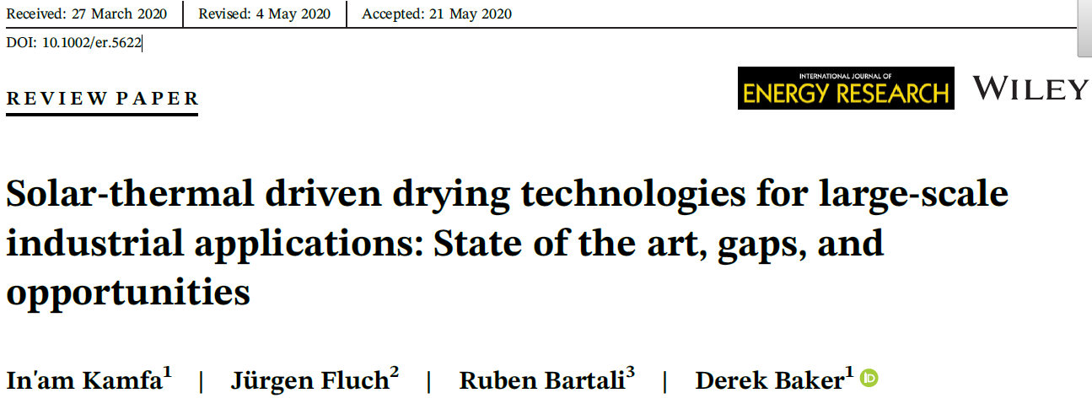
How to Cite |  |  |  |  |  | BibTeX
doi | 10.1002/er.5622 |  |  |  |  | @article{kamfa2020solar,  title={Solar-thermal driven drying technologies for large-scale industrial applications: State of the art, gaps, and opportunities},  author={Kamfa, In'am and Fluch, Juergen and Bartali, Ruben and Baker, Derek},  journal={International Journal of Energy Research},  volume={44},  number={13},  pages={9864--9888},  year={2020},  publisher={Wiley Online Library}  }
MLA | Kamfa, In'am, et al. "Solar‐thermal driven drying technologies for large‐scale industrial applications: State of the art, gaps, and opportunities." International Journal of Energy Research 44.13 (2020): 9864-9888.
APA | Kamfa, I. A., Fluch, J., Bartali, R., & Baker, D. (2020). Solar‐thermal driven drying technologies for large‐scale industrial applications: State of the art, gaps, and opportunities. International Journal of Energy Research, 44(13), 9864-9888.
Chicago | Kamfa, In'am, Juergen Fluch, Ruben Bartali, and Derek Baker. "Solar‐thermal driven drying technologies for large‐scale industrial applications: State of the art, gaps, and opportunities." International Journal of Energy Research 44, no. 13 (2020): 9864-9888.
Harvard | Kamfa, I.A., Fluch, J., Bartali, R. and Baker, D., 2020. Solar‐thermal driven drying technologies for large‐scale industrial applications: State of the art, gaps, and opportunities. International Journal of Energy Research, 44(13), pp.9864-9888.
Vancouver | Kamfa IA, Fluch J, Bartali R, Baker D. Solar‐thermal driven drying technologies for large‐scale industrial applications: State of the art, gaps, and opportunities. International Journal of Energy Research. 2020 Oct 25;44(13):9864-88.
Links to Open Access (OA) Versions
OA Pathway* |  |  |  | Embargo Period? | Link
Published Version*, via Journal Website |  |  |  | No | https://onlinelibrary.wiley.com/doi/full/10.1002/er.5622
Published Version*, via DOI |  |  |  | No | https://doi.org/10.1002/er.5622
Published Version*, via Zenodo |  |  |  | No | https://zenodo.org/record/5159960
Published Version*, via OpenMETU |  |  |  | No | https://open.metu.edu.tr/handle/11511/39725
Creative Commons License
 |  |  | The OA Versions are published using a Creative Commons By Attribution – Non-Commercial – No Derivative (CC BY-NC-ND) License (https://creativecommons.org/licenses/by-nc-nd/4.0/)
Cataloging* |  | Derek K. Baker; SolarTwins; ODTÜ-GÜNAM
* Definitions:
Accepted Version: Also referred to as the Author Accepted Manuscript (AAM), is the accepted version of the manuscript submitted to the journal by the author. The Accepted Version does not include any typesetting or final proofing services provided by the journal to convert the Accepted Version into the Published Version. Thus, the Published Version and Accepted Version are identical in terms of scientific content, but differ in terms of formatting and final proofing.
Cataloging: Information to support internal cataloging of this OA publication.
OA Pathway: Defined using Sherpa Romeo (https://v2.sherpa.ac.uk/romeo/). The definitions for the relevant OA Pathways used to publish this work OA are attached as an appendix to the version of the manuscript published OA.
Published Version: Also referred to as the Version of Record (VoR), is the fully-formatted version of the article as published in the journal.
Smart OA: Guidelines to support Smart OA are published OA at https://zenodo.org/record/5501401.

Non-Peer Reviewed Publications
Portable Publication Sheet (PPS) Sheet for Smart OA*

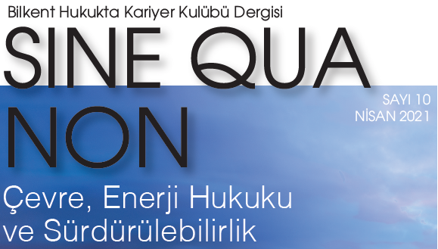 | 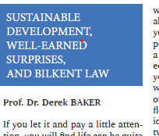

How to Cite |  |  |  |  |  | BibTeX
doi | 10.5281/zenodo.5733154 |  |  |  |  | @article{baker2021sustainable,  title={ Sustainable Development, Well-Earned Surprises, and Bilkent Law},  author={ Baker, Derek},  journal={Sine Qua Non},  volume={10},  pages={5},  year={2021},  publisher={ Bilkent Universitesi Hukukta Kariyer Kulubu}  }
MLA | Derek Baker. "Sustainable Development, Well-Earned Surprises, and Bilkent Law." Sine Qua Non, 10 (2021): 5.
APA | Baker, D. (2021). Sustainable Development, Well-Earned Surprises, and Bilkent Law. Sine Qua Non, 10, 5.
Chicago | Derek Baker. "Sustainable Development, Well-Earned Surprises, and Bilkent Law." Sine Qua Non 10, (2021): 5.
Harvard | Baker, D., 2021. Sustainable Development, Well-Earned Surprises, and Bilkent Law. Sine Qua Non, 10, p.5.
Vancouver | Baker D. Sustainable Development, Well-Earned Surprises, and Bilkent Law. Sine Qua Non. 2021 10:5.
Links to Open Access (OA) Versions
OA Pathway* |  |  |  | Embargo Period? | Link
Published Version*, via Journal Website |  |  |  | No | https://www.hukuktakariyerkulubu.net/sinequanon
Published Version*, via Zenodo |  |  |  | No | https://doi.org/10.5281/zenodo.5733154
Published Version*, via OpenMETU |  |  |  | No | https://hdl.handle.net/11511/94581
Creative Commons License
 |  |  | The OA Versions are published using a Creative Commons By Attribution – Non-Commercial – No Derivative (CC BY-NC-ND) License: https://creativecommons.org/licenses/by-nc-nd/2.0/
Cataloging* |  | Derek K. Baker; SolarTwins; ODTÜ-GÜNAM
* Definitions:
Accepted Version: Also referred to as the Author Accepted Manuscript (AAM), is the accepted version of the manuscript submitted to the journal by the author. The Accepted Version does not include any typesetting or final proofing services provided by the journal to convert the Accepted Version into the Published Version. Thus, the Published Version and Accepted Version are identical in terms of scientific content, but differ in terms of formatting and final proofing.
Cataloging: Information to support internal cataloging of this OA publication.
OA Pathway: Defined using Sherpa Romeo (https://v2.sherpa.ac.uk/romeo/). The definitions for the relevant OA Pathways used to publish this work OA are attached as an appendix to the version of the manuscript published OA.
Published Version: Also referred to as the Version of Record (VoR), is the fully-formatted version of the article as published in the journal.
Smart OA: Guidelines to support Smart OA are published OA at https://zenodo.org/record/5501401.

https://creativecommons.org/licenses/by-sa/4.0/
Grant agreement ID 856619: https://cordis.europa.eu/project/id/856619
https://www.coalition-s.org/
https://zenodo.org/record/5501401 This work is protected by an Attribution-ShareAlike 4.0 International Creative Commons license (CC BY-SA 4.0). https://creativecommons.org/licenses/by-sa/4.0/

